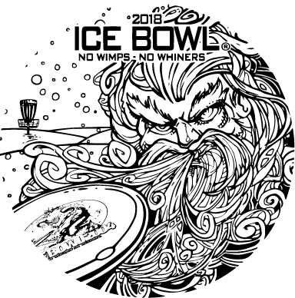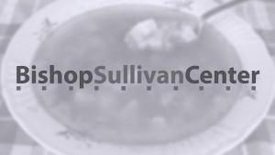

The Kansas City Flying Disc Club Presents
The 31st Annual Kansas City’ Ice Bowl • January 28, 2018 • Swope Park • Kansas City, MO

PLEDGE SHEET FOR GROUPS
Ice Bowl® is an international series of winter disc golf events dedicated to fighting hunger. Since 1996, over $3.75 million have been raised via Ice Bowl® disc golf tournaments. The Kansas City Ice Bowl is a fundraiser for Bishop Sullivan Center’s food pantries. Through the dedication of the Kansas City Flying Disc Club, the KC Ice Bowl, has donated nearly $80,000, including $9,200 in 2014. The Club’s goal for 2018 is $10,000. One hundred percent (100%) of all pledges will be directed to the Bishop Sullivan Center.
The idea behind this pledge sheet is for your disc golf group, club, or organization to help the Kansas City Ice Bowl reach its ambitious goals by asking your friends, family, and coworkers for donations and coming up with other unique fundraising efforts. There are some incentives, listed below, for raising specific amounts of money. However, bragging rights for being the group that raises the most money will be an even greater reward.

Your Name__________________________________________Email_____________________________________Phone_______________________________

I am a member of the _________________________________ (name of group), which has committed itself to raising at least $__________ for the 2018 Kansas City Ice Bowl. I’ll be playing at least 18 holes of disc golf at the KC Ice Bowl and am asking you to help fight hunger in Kansas City by making a pledge for each hole I play. If you prefer, a donation of any amount is appreciated. Thanks for your support. Make checks to either the Bishop Sullivan Center or the Kansas City Flying Disc Club.

Sponsor’s Name Email or phone $$ Donation

________________________________________________________________________________________________________________________

________________________________________________________________________________________________________________________

________________________________________________________________________________________________________________________

________________________________________________________________________________________________________________________

________________________________________________________________________________________________________________________

________________________________________________________________________________________________________________________

________________________________________________________________________________________________________________________

________________________________________________________________________________________________________________________

________________________________________________________________________________________________________________________

________________________________________________________________________________________________________________________

________________________________________________________________________________________________________________________

________________________________________________________________________________________________________________________

________________________________________________________________________________________________________________________

Total of All Pledges________________
Please submit this sheet and the donations at the Ice Bowl, or by February 2, 2018 at Disc Golf World, 2408 NW Vivion Rd, Riverside, MO 64150. Please contact Rick at icebowl@discgolfworld.com or 816.4713.472 or 816.914.0094 with questions.

Incentive gifts: Raise $50 and receive 3 Ice Bowl mini set. $100—1 Premium Ice Bowl Disc & Mini Set. $150—Choice of Any Ice Bowl Disc & Mini Set. $200+—Unique Ice Bowl Disc, Ice Bowl Shirt, & Mini Set. The winning group will receive a very unique prize.

